Screenshots for Acceptance Test “BLAST”
User story: Easy UI design
Screen after starting the program: MainGUI
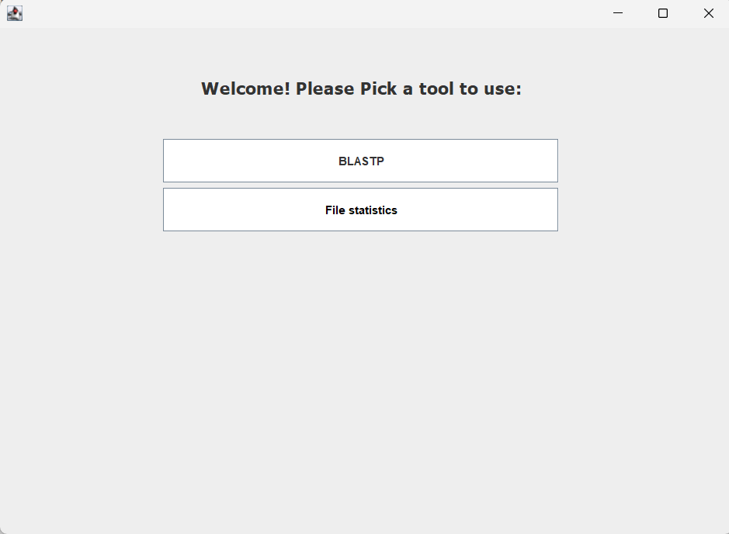
After pressing BLASTP: BlastGUI shows
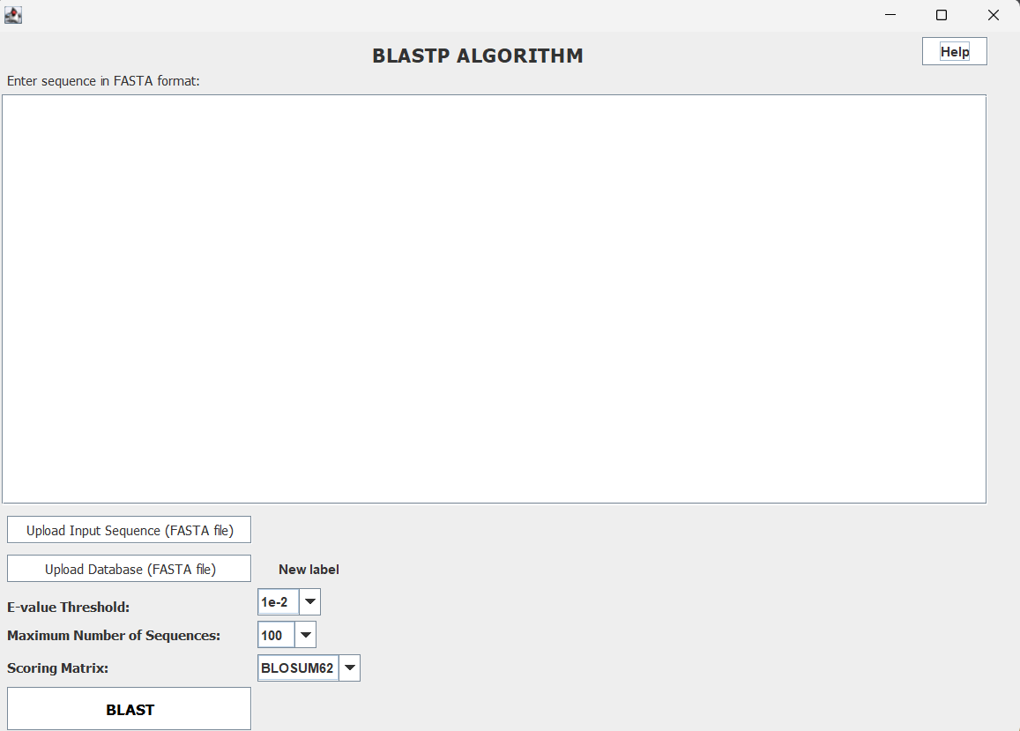
After pressing Help button
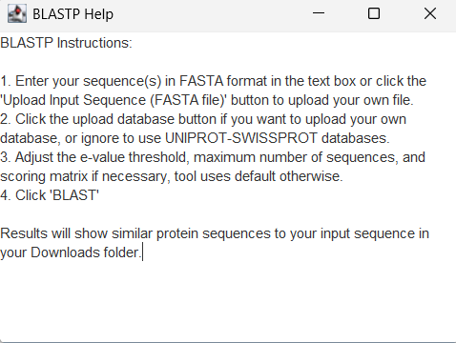

Selecting parameters
